Small pill
Driven by Strategy. Powered by Creativity.
Main Title

Next-Gen Digital Marketing & Creative Agency
Subheading / Description
We help ambitious brands scale faster through data-driven performance marketing, high-converting content, and strategic brand positioning.
Call to Action Buttons
- Primary CTA: Get Started Today →
- Secondary CTA: Explore Our Services
Section Category (Small Label)
About Us
Main Left Headline
We Use Our Experience To Get Clients Results
Top Right Highlight Text
We Are A Digital Agency That Specializes In Web Design, Branding Identity, And Social Media Management. Our Experienced Team Works Closely With Clients To Deliver Customized Solutions That Meet Their Specific Needs.
Right Body Paragraph (Replacing Placeholder Copy)
At Inflix Marketing Solutions, we turn complex digital marketing challenges into clear growth strategies. From high-converting web experiences to targeted social media campaigns, we engineer every touchpoint to capture attention and convert visitors into loyal customers.
Left Box 1: Our Philosophy
We believe marketing should be transparent, data-led, and obsessively focused on ROI—combining bold creativity with actionable metrics to deliver sustained business growth.
Left Box 2: Our Goals
Our goal is to empower ambitious brands to scale seamlessly by providing high-impact digital strategies, driving qualified traffic, and maximizing overall campaign conversion rates.
Section Category (Small Label)
Services
Main Left Headline
What Services We Offer You ?
Top Right Paragraph Copy
We provide growth-driven digital marketing solutions to scale your business online. From target audience acquisition to maximum campaign conversions, we craft data-backed strategies that deliver measurable results.
Card 1: Digital Marketing Strategy
Targeted Meta, Google, and PPC campaigns designed to lower customer acquisition costs and maximize your business ROI.
Card 2: Social Media Marketing
Engaging content strategy, viral reels, and creative campaign management to turn followers into loyal paying customers.
Card 3: Search Engine Optimization (SEO)
Boost your search rankings and drive high-intent, organic traffic directly to your business with tailored SEO tactics.
Card 4: Performance Ads & Analytics
Data-driven ad campaigns optimized continuously to ensure highest lead quality and transparent performance tracking.
Portfolio Item 1
- Category Label: Performance Marketing
- Project Title: E-Commerce Brand – Paid Ads & ROAS Scaling
Portfolio Item 2
- Category Label: Social Media Growth
- Project Title: Local Business – Viral Reel & Engagement Campaign
Portfolio Item 3
- Category Label: Search Engine Optimization
- Project Title: B2B Portal – Organic Traffic & Lead Gen Boost
Portfolio Item 4
- Category Label: Brand Strategy
- Project Title: Tech Startup – Complete Brand Identity & Positioning
Portfolio Item 5
- Category Label: Web & Conversion
- Project Title: High-Converting Landing Page Redesign
Portfolio Item 6
- Category Label: Content Marketing
- Project Title: Influencer Outreach & Campaign Strategy

Our Clients Are Leading Companies And Brands

Client Card Details (6 Cards Grid)
Card 1
- Brand Name: 24 Frames Photography
- Description: Delivered high-impact digital marketing strategies, targeted ads, and social media branding to drive booking inquiries and event leads.
Card 2
- Brand Name: Dr. Shweta PMU Clinic
- Description: Built a premium digital presence with local SEO optimization, patient lead generation, and social media brand positioning.
Card 3
- Brand Name: Mahathi Eco Tech
- Description: Executed B2B lead generation campaigns, strategic web experience, and performance branding for sustainable tech solutions.
Card 4
- Brand Name: Dr. Jaya's Exult Clinic
- Description: Accelerated patient growth and brand authority through targeted social media marketing, aesthetic video reels, and local ads.
Card 5
- Brand Name: Sri Suryodaya
- Description: Enhanced brand visibility and customer reach with performance marketing, local business optimization, and brand positioning.

Card 6
- Category: Branding & Digital Marketing
- Project Title: Dharani Agri Life - Brand Positioning & Marketing
- Short Description: Developed a cohesive brand identity and targeted lead generation campaigns to build market authority in the agricultural sector.
Card 7
- Category: Graphic Design & E-Commerce
- Project Title: Damour Perfumes - Premium Packaging & Ad Creatives
- Short Description: Crafted luxurious visual branding, high-converting product photography assets, and Meta ad creatives for high-end fragrances.
Card 8
- Category: Web Development & SEO
- Project Title: Ron Rehabilitation Center - Website & Local SEO Strategy
- Short Description: Designed an empathetic, accessible responsive website combined with local SEO optimizations to drive patient inquiries.
Section Category (Small Label)
Testimonials
Main Left Headline
What Our Clients Say About Inflix
Right Header Details
- ★★★★★ Average Rating 4.9
- CTA Button: VIEW ALL →
Testimonial Card 1
"Inflix Marketing Solutions completely transformed our digital presence. Their targeted ad campaigns and creative reels brought a massive influx of high-quality patient inquiries to our clinic."
- Rating: ★★★★★
- Name: Dr. Jaya
- Title: Founder, Dr. Jaya's Exult Clinic
Testimonial Card 2
"Working with Inflix was a game-changer for 24 Frames Photography. They structured our social media marketing and brand positioning, directly helping us secure premium event bookings."
- Rating: ★★★★★
- Name: Representative / Team Lead
- Title: Founder, 24 Frames Photography
Testimonial Card 3
"Inflix Marketing Solutions delivered exceptional results for our clinic. Their strategic focus on local SEO and social media campaigns significantly boosted our brand trust and walk-in consults."
- Rating: ★★★★★
- Name: Dr. Shweta
- Title: Founder, Dr. Shweta PMU Clinic
Testimonial Card 4
"The team at Inflix understands how to translate technical offerings into clear B2B marketing strategies. Their performance campaigns helped us generate consistent, high-value leads."
- Rating: ★★★★★
- Name: Management Team
- Title: Director, Mahathi Eco Tech
Testimonial Card 5
"Our brand visibility grew remarkably within just a few months of partnering with Inflix. Their data-driven ad strategy and creative content executed our growth vision perfectly."
- Rating: ★★★★★
- Name: Management Team
- Title: Founder, Sri Suryodaya
Section Category (Small Label)
Our Blog
Main Left Headline Read Our Latest Blogs & Insights
Left Body Paragraph Copy Stay updated with proven marketing strategies, digital trends, and actionable insights. Learn how to optimize your ad spend, build brand authority, and turn online engagement into measurable business growth.
CTA Button VIEW ALL →
Featured Blog Post Card
- Blog Title: How to Build a Digital Marketing Strategy That Guarantees ROI
- Publication Date: March 1, 2026

About Us
Page Header Banner
- Main Title: About Us
- Sub-description: Empowering brands through strategic digital marketing, data-driven growth campaigns, and high-impact visual positioning.
Main Content Section (Below Banner)
Section Label About Us
Main Left Headline We Use Our Experience To Get Clients Results
Top Right Highlight Text We Are A Performance Digital Marketing Agency That Specializes In Paid Acquisition, Brand Identity, SEO, And Strategic Social Media Growth. Our Experienced Team Works Closely With Clients To Deliver Customized Growth Engines That Scalably Lower Customer Acquisition Costs.
Right Sub-paragraph (Replacing Placeholder Copy) At Inflix Marketing Solutions, we bridge the gap between creative execution and quantifiable revenue. From medical clinics to eco-tech enterprises, we craft bespoke strategies designed to convert impressions into loyal, long-term clients.
Our Philosophy (Left Box 1) We believe marketing should be transparent, data-led, and obsessively focused on ROI—combining bold creative strategy with actionable metrics to deliver sustained business growth.
Our Goals (Left Box 2) Our goal is to empower ambitious brands to scale seamlessly by executing targeted performance ads, maximizing conversions, and building dominant online market presence.
Section Category (Small Label) Why Us ?
Main Left Headline Because We Are The Best Creative Agency!
Top Right Paragraph Copy At Inflix Marketing Solutions, we combine data-backed strategies with compelling storytelling to maximize your marketing investment. We focus on building scalable growth channels tailored to your brand’s specific needs.
Point 01. More Innovation We deploy modern performance marketing tactics and creative content formats that keep your brand ahead of market trends.
Point 02. Proven Expertise Our team has a track record of driving revenue growth and qualified leads across diverse industries, from healthcare to tech.
Point 03. Strategic Vision Every campaign is backed by thorough market research and conversion-focused planning to ensure measurable, long-term ROI.
Services Page Header Banner
- Main Title: Services
- Sub-description: Comprehensive digital marketing solutions engineered to accelerate brand visibility, drive qualified leads, and maximize long-term business ROI.
Section Header
- Section Category (Small Label): Services
- Main Left Headline: What Services We Offer You ?
- Top Right Paragraph Copy: At Inflix Marketing Solutions, we deliver end-to-end performance marketing and strategic digital management. We build customized, multi-channel growth systems that lower customer acquisition costs.
Service Cards (8-Grid Layout)
Card 1: Branding Identity We craft distinct brand logos, style guides, and positioning frameworks that build instant marketplace authority and client trust.
Card 2: Web Development High-converting, responsive websites engineered for ultra-fast loading speeds, smooth user journeys, and seamless lead capture.
Card 3: UI/UX Design User-centric interfaces and wireframes designed to guide visitors intuitively through your marketing funnel to boost conversion rates.
Card 4: Graphic Design High-impact visual creatives, promotional banners, and social assets crafted to capture attention across all digital touchpoints.
Card 5: Performance Marketing Data-driven Meta, Google, and PPC campaigns structured specifically to target high-intent clients and scale return on ad spend (ROAS).
Card 6: Video Creation & Reels Engaging short-form video content, ad creatives, and promotional reels built to boost organic reach and drive active engagement.
Card 7: Copywriting & Content Persuasive website copy, ad scripts, and strategic messaging that communicate your brand value and drive viewers to take action.
Card 8: Social Media Management End-to-end account management, content calendar planning, and audience engagement strategies tailored to establish industry authority.
Process Section Header
- Section Category (Small Label): Process
- Main Right Headline: Our Smooth Workflow
- Right Paragraph Copy: We follow a structured, step-by-step methodology to ensure every marketing campaign is executed seamlessly, optimized in real-time, and built to achieve maximum profitability.
- Video CTA Button: WATCH VIDEO
Process Steps (4 Grid Cards)
- 01. Discovery & Strategy: We analyze your business goals, target audience, and competitive landscape to build a customized growth blueprint.
- 02. Content & Creative Development: Our team crafts high-converting ad copy, visual assets, and strategic marketing materials aligned with your brand identity.
- 03. Campaign Execution & Ads: We deploy multi-channel ad campaigns across Meta, Google, and social platforms with precise targeting.
- 04. Analytics & Continuous Scaling: We track performance metrics constantly, refining campaign tactics to maximize lead quality and lower acquisition costs.

FAQs Section
- Section Category (Small Label): FAQs
- Main Left Headline: Frequently Asked Questions
- Left Sub-paragraph Copy: Have questions about working with us? Here are answers to common questions about our services, campaign strategies, and client onboarding process.
- CTA Button: VIEW ALL →
FAQ Items (Accordion List)
Q1. How does Inflix Marketing Solutions help grow my business?
- Answer: We build data-driven digital marketing systems tailored to your business, utilizing performance ads, conversion rate optimization, and brand positioning to drive consistent leads and scale revenue.
Q2. How long does it take to see results from marketing campaigns?
- Answer: Paid advertising campaigns often generate immediate traffic and leads within days of launch, while SEO and brand positioning build sustained organic growth over 3 to 6 months.
Q3. What industries do you specialize in?
- Answer: We work with a diverse range of clients, including healthcare and specialized clinics, B2B enterprises, professional service providers, local businesses, and creative photography studios.
Q4. What services are included in your growth packages?
- Answer: Our packages are customized based on your business needs, offering performance ad management (Meta/Google), social media strategy, web development, SEO, graphic design, and video production.

Individual page
1. Branding Identity
- Hero Title: Branding Identity Services
- Hero Sub-description: Build a powerful, memorable, and unique brand visual identity that captivates your ideal audience and establishes immediate market trust.
- Overview Section Title: Strategic Brand Building That Sets You Apart
- Overview Main Content: Your brand is more than just a logo—it’s the total experience your customers have with your business. At Inflix Marketing Solutions, we craft cohesive brand identities that communicate your company’s values, authority, and unique selling propositions clearly.
- Key Features / Deliverables:
  - Brand Strategy & Positioning: Defining your target audience, core messaging, and competitive positioning.
  - Logo Design & Identity System: Creating versatile primary and secondary logos designed for modern digital platforms.
  - Visual Style Guidelines: Detailed brand guidelines covering typography, color palettes, icon styles, and image usage.
  - Brand Touchpoints: Designing business cards, stationery, social media headers, and marketing collateral.

2. Web Development
- Hero Title: Web Development & Design
- Hero Sub-description: High-performing, fast-loading, and responsive websites engineered to convert casual visitors into paying customers.
- Overview Section Title: Custom Digital Solutions Built For Scalable Growth
- Overview Main Content: A company's website is its primary digital storefront. We build modern, secure, and mobile-responsive websites designed around seamless user journeys and conversion optimization.
- Key Features / Deliverables:
  - Custom Responsive Web Design: Optimized for perfect display across smartphones, tablets, and desktop devices.
  - Speed & Performance Optimization: Clean code architecture to ensure lightning-fast page loading times.
  - SEO-Friendly Architecture: On-page technical SEO structure to maximize organic Google visibility.
  - Conversion Rate Optimization (CRO): Strategic Call-To-Action (CTA) placement and lead capture forms.

3. UI/UX Design
- Hero Title: UI/UX Design Services
- Hero Sub-description: Intuitive, aesthetic, and user-centric web and mobile interfaces that deliver seamless digital experiences.
- Overview Section Title: User Experience Strategy That Boosts Engagement
- Overview Main Content: Great design goes beyond aesthetics—it solves user friction. Our UI/UX design process focuses on understanding consumer behavior to build intuitive navigation flows that guide users effortlessly toward conversion.
- Key Features / Deliverables:
  - User Research & Wireframing: Mapping out user journeys and structural interactive wireframes.
  - Interactive Prototyping: Clickable high-fidelity prototypes to visualize digital products before development.
  - Interface Design (UI): Modern visual interfaces aligned with your brand guidelines.
  - Usability Testing: Refining layout structures based on real user interactions and behavior data.

4. Graphic Design
- Hero Title: Graphic Design Services
- Hero Sub-description: Eye-catching visual assets and promotional designs crafted to capture attention across all physical and digital channels.
- Overview Section Title: Creative Visual Storytelling For Modern Brands
- Overview Main Content: In a visually crowded digital landscape, high-quality graphics are essential to cut through the noise. We produce compelling designs for advertising campaigns, social channels, and marketing materials.
- Key Features / Deliverables:
  - Ad Campaign Creatives: High-converting banner ads for Meta (Facebook/Instagram) and Google Ads.
  - Social Media Graphics: Engaging post templates, story layouts, and promotional banners.
  - Marketing Materials: Professional brochures, flyers, pitch decks, and email newsletters.
  - Print Design: Packaging, banner prints, and corporate branding assets.

5. Performance Marketing / Paid Ads
- Hero Title: Performance Marketing & PPC
- Hero Sub-description: Data-driven ad campaigns designed to generate high-quality leads, lower acquisition costs, and maximize ROAS.
- Overview Section Title: Scalable Customer Acquisition Engines
- Overview Main Content: Stop wasting budget on vanity metrics. Our performance marketing strategies leverage precision audience targeting, A/B ad testing, and real-time optimization across Meta, Google, and LinkedIn to generate predictable business growth.
- Key Features / Deliverables:
  - Meta Ads (Facebook & Instagram): Highly targeted lead generation and retargeting campaigns.
  - Google Search & PPC Ads: Capturing high-intent customer search queries at the exact moment of demand.
  - Funnel Building & Analytics: End-to-end tracking setups to monitor conversion data and CAC.
  - Ad Creative & Copy Testing: Continuous testing of visual hooks and copy to improve click-through rates.

6. Video Creation & Reels
- Hero Title: Video Creation & Motion Media
- Hero Sub-description: Dynamic short-form video production, ad creatives, and promotional reels built to maximize audience engagement.
- Overview Section Title: High-Impact Video Content That Drives Conversions
- Overview Main Content: Video content is currently the highest-performing media type across all social platforms. We script, edit, and produce high-converting short-form reels, product showcases, and brand videos designed to keep viewers engaged.
- Key Features / Deliverables:
  - Short-Form Reels & Shorts: Dynamic 15–60 second video edits tailored for Instagram, YouTube Shorts, and TikTok.
  - Performance Video Ads: High-hook direct response ads built to boost ad conversions.
  - Motion Graphics & Animations: Eye-catching visual effects, text overlays, and graphic transitions.
  - Video Scriptwriting & Editing: Strategic messaging, audio balancing, and color grading.

7. Copywriting & Content Creation
- Hero Title: Copywriting & Content Strategy
- Hero Sub-description: Persuasive ad copy, website content, and marketing scripts that turn audience interest into sales transactions.
- Overview Section Title: Words That Sell And Build Marketplace Authority
- Overview Main Content: Great design gets attention, but compelling copywriting closes the sale. We write clear, action-oriented messaging that resonates with your target audience and communicates your unique market value clearly.
- Key Features / Deliverables:
  - Sales & Landing Page Copy: High-converting direct response website copy structured for lead capture.
  - Ad Copywriting: High-hook messaging for social media ads and Google search listings.
  - SEO Blog & Content Creation: Value-driven article content written to rank on search engine results.
  - Email Marketing Copy: Nurture sequences and sales outreach emails designed for open and click rates.

8. Digital Marketing & Social Media Management
- Hero Title: Social Media & Digital Marketing
- Hero Sub-description: Comprehensive social media growth management, SEO, and multi-channel marketing campaigns that scale your digital footprint.
- Overview Section Title: Full-Funnel Digital Growth & Online Management
- Overview Main Content: Establish market leadership with a structured digital marketing campaign. We manage your complete online presence—combining organic social media growth, SEO optimization, and audience engagement strategies.
- Key Features / Deliverables:
  - Social Media Strategy & Management: Content calendar planning, posting, and profile optimization.
  - Search Engine Optimization (SEO): Technical, on-page, and off-page SEO strategies for organic rankings.
  - Audience Engagement & Community: Active management and engagement to cultivate a loyal follower base.
  - Monthly Performance Reporting: Comprehensive analytics reports showing traffic, lead growth, and ROI metrics.
Portfolio Page Header Banner
- Main Title: Portfolio
- Sub-description: Explore our collection of performance campaigns, brand transformations, web builds, and creative visual projects delivered for our clients.
Section Header
- Section Category (Small Label): Portfolio
- Main Left Headline: Check Out Our Latest Projects
- Top Right Paragraph Copy: Explore how we combine strategy, design, and performance marketing to deliver measurable growth, strong brand identities, and high-converting digital assets.
1. 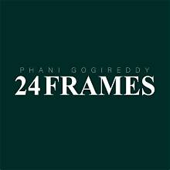
2.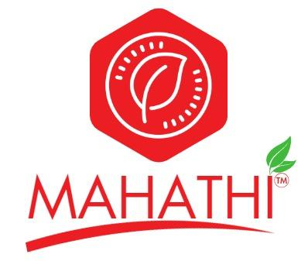
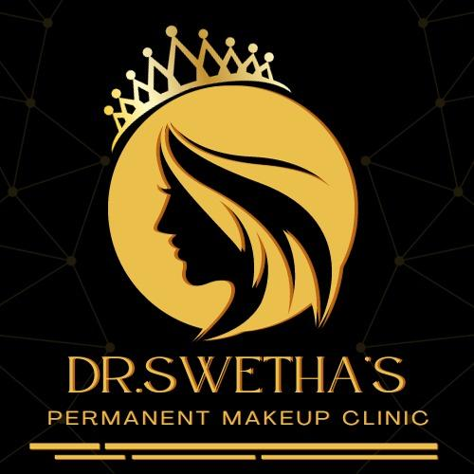
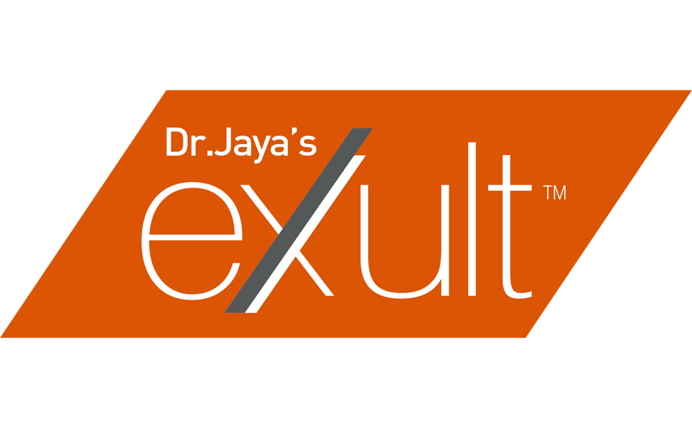

3.